University Academic Portal Interface Design

A
Human Computer Interface Course Project Report
in partial fulfilment of the degree

Bachelor of Technology
in
Computer Science & Engineering

By
M.Shreya 2403A51020
S.Kavya 2403A51037
R.Maneesha 2403A51040
P.Srivarshini 2403A51051

Under the guidance of
Syed Nawaz Pasha
Assistant Professor

Submitted to
School of Computer Science and Artificial Intelligence




DEPARTMENT OF COMPUTER SCIENCE & ENGINEERING

CERTIFICATE

This is to certify that the Human Computer Interface - Course Project Report entitled
“Emotion-Based Music” is a record of bonafide work carried out by the students M.Shreya , S.Kavya , R.Maneesha , P.Srivarshini bearing 2403A51020, 2403A51037, 2403A51040, 2403A51051 during the academic year 2026-27 in partial fulfillment of the award of the degree of Bachelor of Technology in Computer Science & Engineering by the Jawaharlal Nehru Technological University, Hyderabad.

Supervisor Head of the Department

Mr. Syed Nawaz Pasha Dr. CH. Sandeep
Asst. Professor Associate Professor and HOD
School of CS & AI School of CS & AI
SR University SR University
Ananthasagar, Warangal. Ananthasagar, Warangal.

ABSTRACT

The Emotion Based Music App is an intelligent music recommendation system that suggests songs based on the user's emotional state. The primary objective of this application is to enhance user experience by automatically selecting music that matches different moods such as happy, sad, relaxed, angry, or energetic. The system identifies emotions through user input, facial expression recognition, or manual mood selection. Based on the detected emotion, suitable songs are retrieved from a categorized music database to provide personalized recommendations.

A key feature of this application is the mood constellation, which allows users to transition from one mood to another. Instead of selecting only a single emotion, users can choose both their current mood and their desired mood, such as sad to happy, stressed to calm, or tired to energetic. The system then generates a playlist that gradually shifts the emotional tone of the music, helping users move smoothly between moods. This creates a dynamic and adaptive listening experience.

The proposed system uses machine learning techniques for emotion classification and recommendation algorithms to map emotions to appropriate songs. The application also includes features such as playlist generation, user-friendly interface, and real-time mood selection. The interface is designed to be simple and interactive so that users can easily select moods and explore recommended songs.

This application helps reduce the time spent searching for music and improves emotional well-being by delivering context-aware recommendations. By combining emotion recognition with mood transition capabilities, the Emotion Based Music App provides a smarter and more personalized music experience. Overall, the system demonstrates how technology can understand human emotions and guide users through mood changes using intelligent music recommendations.

Table of Contents

- Introduction 1
- Problem Statement 2
- Objectives of the Project 3
- Target Users 4
- User Personas 5
- UX Design Process 10
- UI Design Elements 12
- Wireframes 14
- Prototype 19
- Final UI Screens 20
- Usability Considerations 27
- Conclusion 28

1. Introduction

Music plays an important role in human life by influencing emotions, mood, and mental well-being. People often choose music based on how they feel, such as listening to happy songs when they are joyful or calm music when they are stressed. However, manually selecting songs that match one’s emotional state can be time-consuming and sometimes difficult.
An Emotion-Based Music App is designed to solve this problem by automatically detecting the user’s emotions and recommending suitable music. The app uses technologies such as Artificial Intelligence (AI), facial recognition, or user input to identify emotions like happiness, sadness, anger, or relaxation. Based on the detected mood, it suggests songs that enhance or balance the user’s emotional state.
This application aims to provide a personalized and user-friendly music experience. By combining emotion detection with smart music recommendation systems, the app helps users enjoy music that matches their feelings without manual searching. It can also improve mental health by offering comforting or uplifting music when needed. Overall, the Emotion-Based Music App represents an innovative integration of technology and entertainment, making music listening more interactive, intelligent, and emotionally connected.

1

2. Problem Statement

In today’s digital world, music streaming platforms provide access to millions of songs, but they lack the ability to truly understand a user’s emotional state. Users often spend a significant amount of time searching for music that matches their mood, which can be inconvenient and inefficient. Additionally, selecting appropriate music manually may not always reflect the user’s current feelings accurately.
Most existing music applications rely on basic filters such as genre, artist, or previously played tracks, rather than real-time emotional analysis. As a result, they fail to deliver a personalized and emotionally relevant listening experience.
The problem is to develop a smart system that can automatically detect a user’s emotions—through facial expressions, voice, or user input—and recommend music accordingly. The system should be able to provide accurate, real-time suggestions that align with the user’s mood, improving user satisfaction and enhancing the overall music listening experience.

2

3. Objectives of the Project

The main objective of the Emotion-Based Music App is to develop an intelligent system that can detect the user’s emotional state and provide personalized music recommendations accordingly. The project aims to reduce the effort required for manual song selection by automatically suggesting music that matches the user’s mood, thereby enhancing the overall listening experience. It also focuses on integrating Artificial Intelligence and machine learning techniques to improve the accuracy of emotion detection and recommendation over time. Additionally, the application seeks to create a simple and user-friendly interface, support multiple mood categories, and deliver realtime responses. Ultimately, the goal is to make music listening more interactive and meaningful while also contributing to the user’s mental well-being by offering appropriate and mood-enhancing music.

3

4. Target Users

The Emotion Based Music App is designed for a wide range of users who listen to music based on their mood and emotions. The main target users include students who use music to concentrate, relax, or reduce stress during studies. Working professionals are also target users, as they often listen to music to improve productivity or unwind after work.

The application is useful for teenagers and young adults who frequently experience mood changes and prefer personalized music recommendations. It also benefits people who want emotional support through music, such as individuals feeling stressed, sad, or anxious. Fitness enthusiasts can use the app to select energetic music for workouts, while travelers can enjoy mood-based playlists during journeys.

Additionally, music lovers who want a smart and personalized listening experience are important target users. The mood constellation feature is especially helpful for users who want to gradually change their mood, such as moving from sad to happy or tired to energetic. Overall, the app is suitable for anyone who wants music that matches their emotions and enhances their listening experience.

4

5. User Personas

1. Student User – Stress Relief Listener

Name: Ananya
Age: 20
Occupation: BTech Student Goals:

Listen to music while studying
Reduce exam stress
Stay focused

Needs:

Calm and concentration playlists
Quick mood selection

Smooth transition from stressed → relaxed

How App Helps:
Ananya selects "Stressed" as current mood and "Calm" as desired mood. The app generates a playlist that gradually relaxes her mind.

5
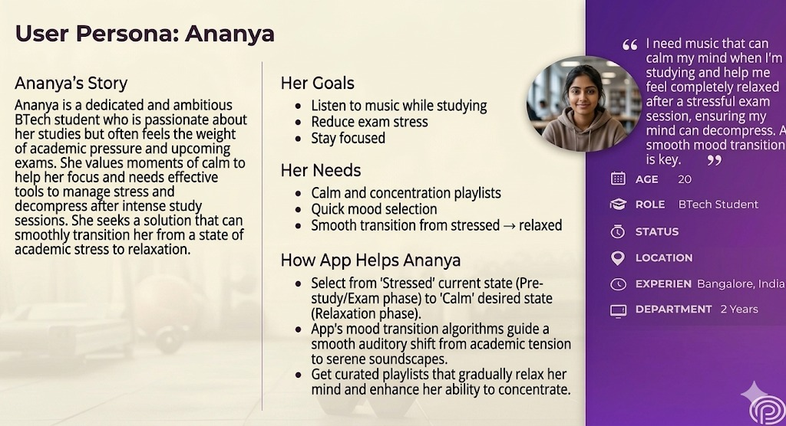
2. Working Professional – Productivity Booster

Name: Rahul
Age: 28
Occupation: Software Engineer Goals:

Stay productive during work
Relax after office hours

Needs:

Energetic songs for work
Relaxing music after work
Easy navigation
How App Helps:

Rahul chooses "Tired" → "Energetic" during morning and "Stressed" →
"Relaxed" after work. The mood constellation feature creates suitable playlists.

6
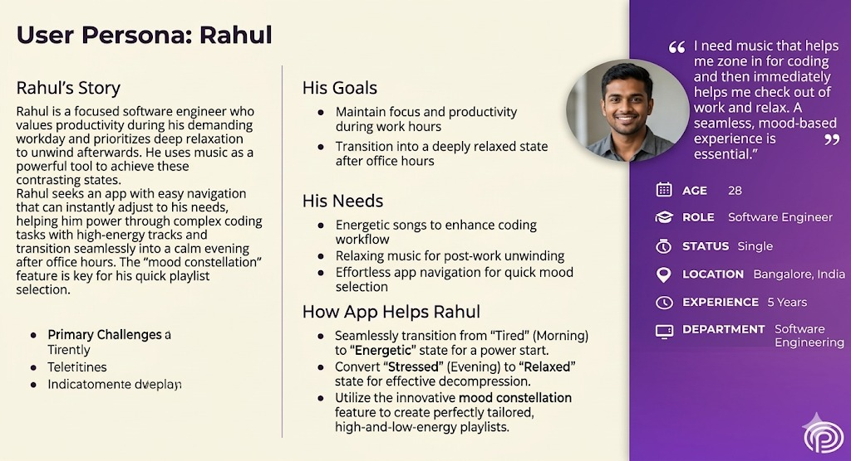

3. Fitness Enthusiast – Workout Motivator

Name: Priya
Age: 24
Occupation: Fitness Trainer Goals:

Stay motivated during workouts
Maintain energy levels

Needs:

High-energy songs
Quick playlist generation

How App Helps:

Priya selects "Normal" → "Energetic" and gets fast-paced songs for her workout
session.
7
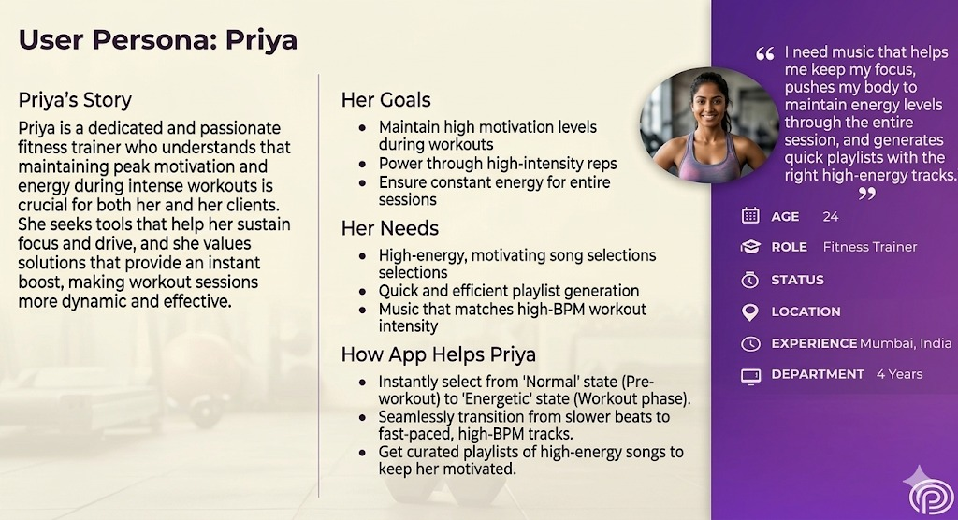
4. Music Lover – Emotional Listener

Name: Karan
Age: 22
Occupation: College Student Goals:

Listen to music based on mood
Explore new songs

Needs:

Personalized recommendations
Mood transition playlists

How App Helps:
Karan selects "Sad" → "Happy". The app gradually lifts his mood through curated songs.

8

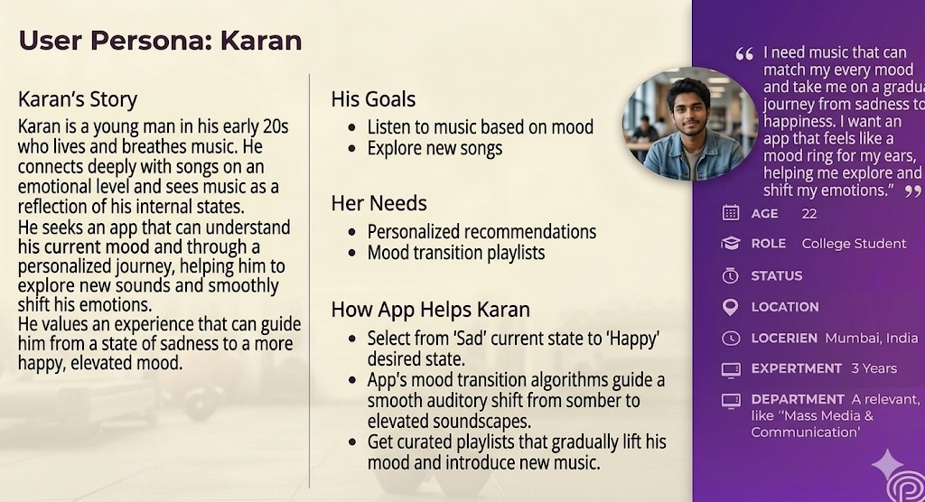

9

6. UX Design Process
The UX design process for the Emotion Based Music App focuses on creating a simple, user-friendly, and interactive experience. The design process follows several stages to ensure the application meets user needs effectively.

- User Research
In this stage, user needs and behaviors are analyzed. The target users such as students, professionals, and music lovers are identified. Their problems, like difficulty in finding mood-based songs, are studied. This helps in understanding what features users expect, such as mood selection and mood constellation.

- Define Requirements
Based on research, the main features are defined. These include mood detection, mood constellation (mood transition), playlist generation, and simple navigation. The goal is to make the app easy to use and emotionally responsive.

- Ideation
Different ideas and solutions are generated. Designers plan how users will select moods, how playlists will appear, and how the mood transition will work. Layout structure and feature placement are decided in this stage.

- Wireframing
Low-fidelity wireframes are created to show the basic layout of screens. These include login screen, mood selection screen, mood constellation screen, playlist screen, and player screen. Wireframes focus on structure without colors or detailed design.

10

5.UI Design
High-fidelity UI screens are designed by adding colors, icons, typography, and visual elements. Mood icons, buttons, and music cards are styled to make the interface attractive and easy to use.

- Prototyping
Interactive prototypes are created to simulate the app flow. Users can click through screens like selecting mood → choosing desired mood → viewing playlist. This helps in understanding user interaction.

- Testing
The design is tested with users to identify usability issues. Feedback is collected to improve navigation, readability, and overall experience.

- Final Design
After improvements, the final UI is prepared. The Emotion Based Music App provides a smooth and personalized experience with mood-based music recommendations and mood constellation transitions.

11

7. UI Design Elements
The UI design elements define the visual components used in the Emotion Based Music App to create an attractive and user-friendly interface. These elements help users easily interact with the application and navigate through features smoothly.

1. Color Palette
Soft and expressive colors are used to represent different moods. For example, blue for calm, yellow for happy, red for energetic, and purple for relaxed. The color scheme helps users quickly understand mood categories and improves visual appeal.

2. Typography
Simple and readable fonts are used for better user experience. Headings are slightly bold to highlight important sections, while body text is kept clean and minimal. Proper font size and spacing improve readability.

3. Icons
Mood icons such as happy, sad, calm, and energetic are used for quick identification. Icons are also used for play, pause, next, and playlist options. These icons make the interface intuitive and easy to understand.

12
4. Buttons Buttons are used for mood selection, playlist generation, and navigation. Rounded buttons with clear labels improve usability. Primary buttons highlight main actions like “Select Mood” or “Generate Playlist.”

5. Cards
Music recommendations are displayed using cards. Each card shows song title, artist name, and album image. Cards help organize content neatly and improve readability.

6. Navigation Bar
A bottom or top navigation bar is used for easy movement between screens such as Home, Mood Selection, Playlist, and Profile. This helps users quickly access different features.

7. Images and Album Art
Album cover images are used to make the interface visually engaging.
Images also help users identify songs easily.

8. Mood Constellation Visual
A graphical representation is used to show mood transition from one emotion to another. This may include circular layout or connected nodes showing mood flow.

9. Spacing and Layout
Proper spacing between elements improves clarity and avoids clutter. A clean layout ensures smooth navigation and better user experience.
13
8. Wireframes
Wireframes were created as low-fidelity representations of the system. These sketches helped define the layout and structure of each page without focusing on visual details.
They played a crucial role in planning navigation flow, ensuring that users can move seamlessly between different sections. Wireframes also helped identify potential usability issues early in the design process.
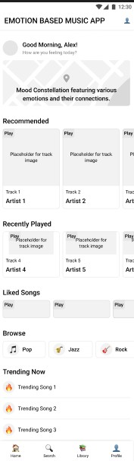

14
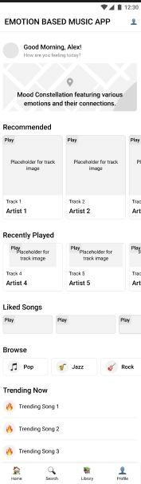

15
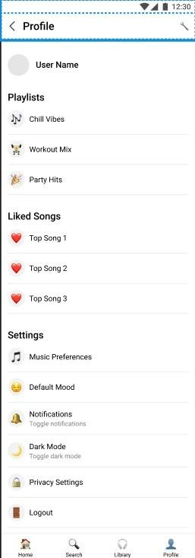

16
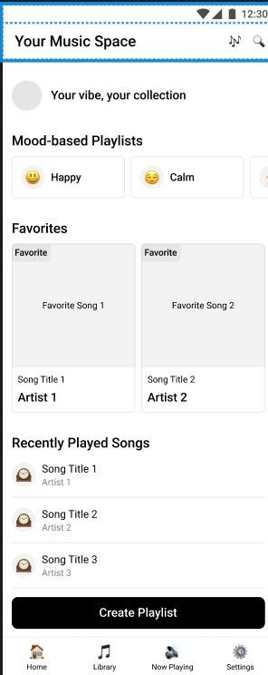

17
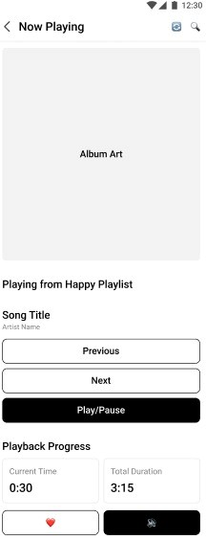

18

9. Prototype
The prototype of the Emotion-Based Music App represents a basic working model that demonstrates how the application functions and interacts with users. It includes key screens such as the login page, home screen, emotion detection interface, and music recommendation page. In the prototype, users can either allow the app to detect their emotions using the camera or manually select their current mood from given options like happy, sad, or relaxed. Based on the selected or detected emotion, the app displays a list of recommended songs or playlists that match the user’s mood.
The prototype is designed with a simple and user-friendly interface, focusing on easy navigation and clear visual elements such as icons, buttons, and mood indicators. Tools like Figma can be used to create interactive prototypes where users can click through different screens to experience the app flow. Although it may not include full backend functionality, the prototype effectively illustrates the concept, design, and user experience of the final application. https://www.figma.com/design/vVKQT1bWPdyx3t8p2bxw5A/Untitled? node-id=0-1&t=IIHMFtrbtOHEHuqo-1
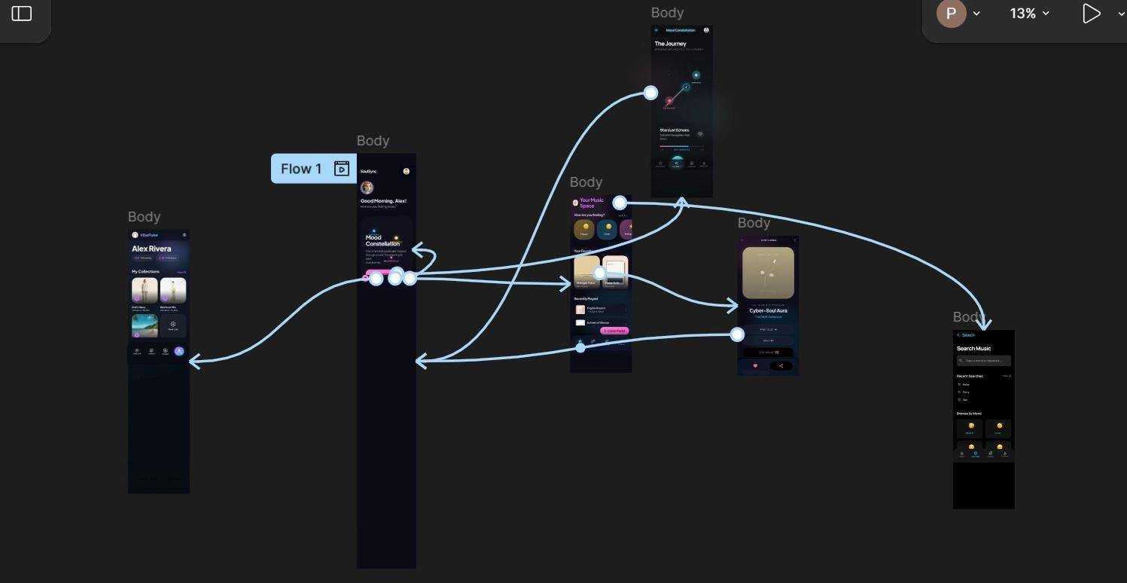

19

10. Final UI Screens
The final UI of the Emotion-Based Music App is designed to be simple, attractive, and easy to navigate, ensuring a smooth user experience. The main screens included in the application are:

1. Splash Screen
This is the first screen displayed when the app is opened. It shows the app logo, name, and a visually appealing background related to music and emotions.
- Login / Sign-Up Screen
Allows users to create an account or log in using their credentials. It may also include options for social media login.
- Home Screen
The central dashboard where users can access features such as emotion detection, mood selection, and recommended playlists. It may also display recently played songs.
- Emotion Detection Screen

This screen uses the device camera (or input method) to detect the user’s facial expressions or allows manual mood selection (happy, sad, angry,
relaxed, etc.).
- Music Recommendation Screen
Displays a list of songs or playlists based on the detected or selected emotion. Each song includes details like title, artist, and play option.
- Now Playing Screen
Shows the currently playing song with controls such as play, pause, next, previous, volume, and progress bar.
- Playlist / Library Screen
Allows users to view saved songs, favorite playlists, and recently played tracks.

20

- Profile Screen
Contains user details, settings, preferences, and options to log out or manage the
account.

21
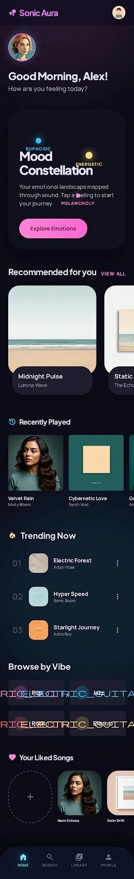

Figure1: Home Screen

22
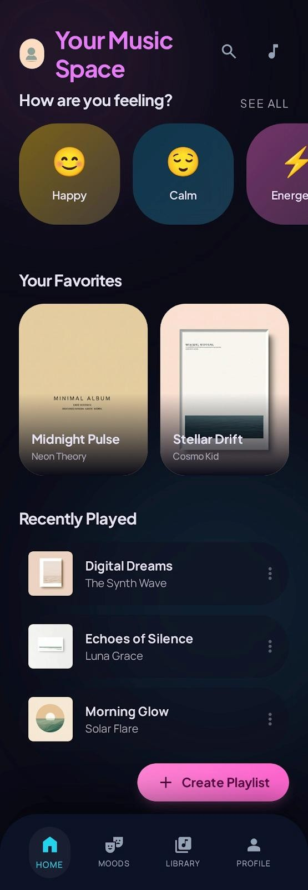

Figure 2: Profile

23
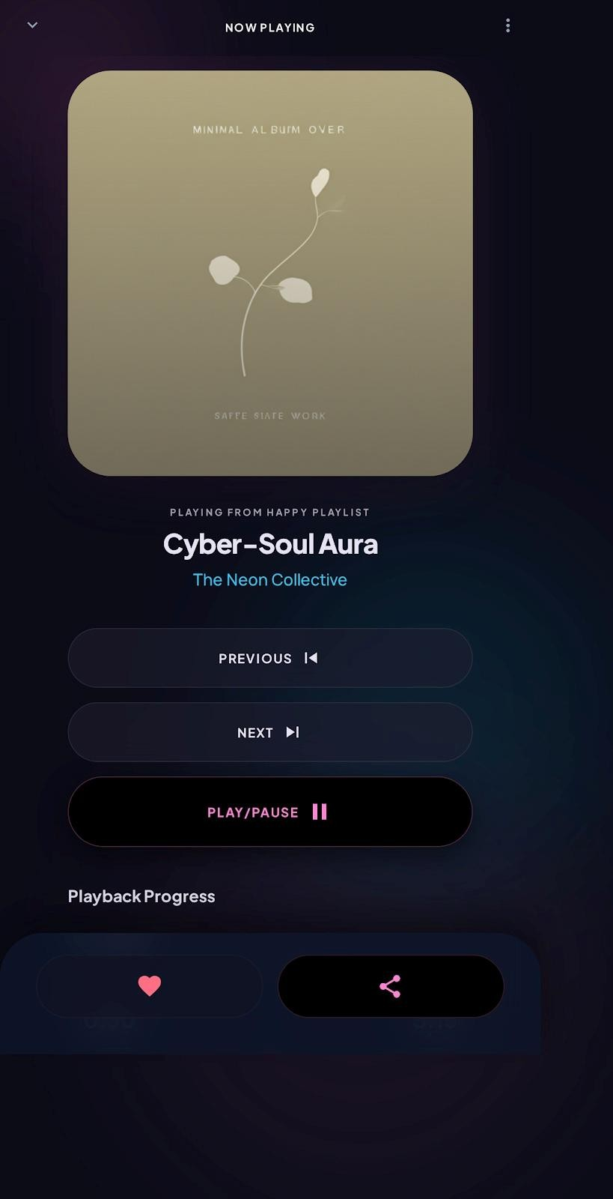

Figure 3 : Song Playing Screen

24
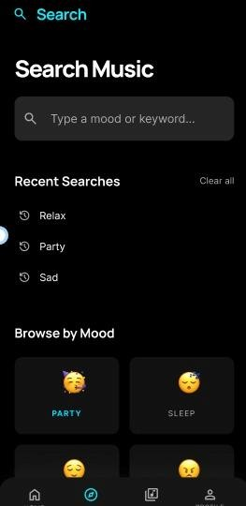

Figure 4:Search

25
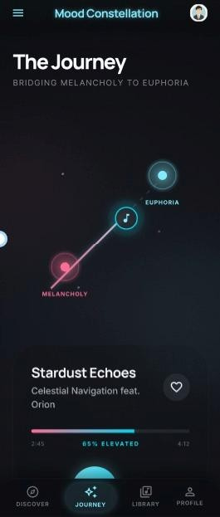

Figure 5:Mood Change Jounery Screen

26

11. Usability Considerations
Usability is an important aspect of the Emotion-Based Music App to ensure that users can easily interact with the application and enjoy a smooth experience. The app is designed with a simple and intuitive interface so that users of all age groups can navigate it without confusion. Clear icons, readable fonts, and consistent color schemes are used to make the interface visually appealing and easy to understand.
The app provides quick access to main features such as emotion detection and music recommendations, reducing the number of steps required to perform actions. It also ensures fast response time so that users receive music suggestions instantly based on their mood. Error handling and feedback mechanisms are included to guide users in case of issues, such as camera access problems or incorrect inputs.
Additionally, the app supports accessibility features like adjustable text size and easy navigation to accommodate different user needs. Privacy and security are also considered, especially when using camera-based emotion detection, ensuring that user data is handled safely. Overall, the focus is on making the app efficient, responsive, and user-friendly to deliver a satisfying experience.

27

12. Conclusion

The Emotion-Based Music App presents an innovative solution to enhance the way users interact with music by combining technology with human emotions. By detecting the user’s mood and providing personalized music recommendations, the app simplifies the process of finding suitable songs and creates a more engaging listening experience. It reduces manual effort, saves time, and ensures that users always have access to music that matches their feelings.
The project also demonstrates the effective use of Artificial Intelligence and usercentered design to build a smart and responsive application. With its simple interface, real-time performance, and focus on emotional well-being, the app has the potential to improve users’ daily lives. Overall, the Emotion-Based Music App highlights how modern technology can make entertainment more meaningful, interactive, and personalized.

28

